Dracula

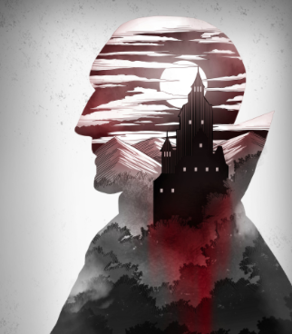

by bram stoker

Chapter 1: Count Dracula

|  |
| --- |
| *Plot elements*  ***PLOT:*** A series of related events in a story, beginning with a problem and ending with the solution of that problem.  ***CHARACTER:*** The people or animals that carry out the action of the story.   * A ***PROTAGONIST*** is the leading or major character in a story. * An ***ANTAGONIST*** is the character who opposes the protagonist.   ***SETTING:*** The time AND place of the story.   * The time could be hour, day, year, season, and/or historical era.   ***CONFLICT:*** The major problem in the story that needs to be resolved. |

While reading, identify the following plot elements:

**The Protagonist:**

**The Antagonist:**

**Setting** information (describe the place):

|  |  |
| --- | --- |
| Setting 1: |  |
| Setting 2: | Castle Dracula and the two rooms: |

The **Conflict** in the story is:

Chapter 2: I am in danger

|  |
| --- |
| *Plot element*  ***RISING ACTION:*** Events that develop because of the conflict. |

**Setting** information (describe the place):

|  |  |
| --- | --- |
| Setting 1: |  |
| Setting 2: |  |
| Setting 3: |  |
| Setting 4: |  |

**Rising actions** (Write a short description of the event):

|  |
| --- |
| 1. |
| 2. |
| 3. |
| 4. |
| 5. |

Chapter 3: Lucy in danger

**Setting** information (describe the place and time):

|  |  |
| --- | --- |
| Setting 1:  Whitby – write about the different times and places |  |
| Setting 2: |  |
| Setting 3: |  |

**Rising actions** (Write a short description of the event):

|  |
| --- |
| 1. |
| 2. |
| 3. |
| 4. |
| 5. |
| 6. |
| 7. |
| 8. |

Chapter 4: Lucy’s death

**Setting** information (describe the place and time):

|  |  |
| --- | --- |
| Setting 1: |  |
| Setting 2: |  |
| Setting 3: |  |
| Setting 4: |  |

**Rising actions** (Write a short description of the event):

|  |
| --- |
| 1. |
| 2. |
| 3. |
| 4. |
| 5. |
| 6. |
| 7. |
| 8. |

Chapter 5: Mina in danger

|  |
| --- |
| *Plot element*  ***CLIMAX:*** This is the story’s most emotional or suspenseful moment.   * The two opposing forces are deep in conflict at this point. It is clear that one side is about to win while the other side is about to lose. |

**Setting** information (describe the place):

|  |  |
| --- | --- |
| Setting 1: |  |
| Setting 2: |  |
| Setting 3: |  |
| Setting 4: |  |

The **Climax** of the story is:

Chapter 6: Dracula must die

|  |
| --- |
| *Plot element*  ***FALLING ACTION:*** The point in the story when the conflict is nearly resolved.  ***RESOLUTION:*** The last part of the story when the conflict is resolved, and the story comes to a close. |

**Setting** information (describe the place):

|  |  |
| --- | --- |
| Setting 1: |  |
| Setting 2: |  |
| Setting 3: |  |
| Setting 4: |  |

The **Falling Action**:

The **Resolution**: