By: Alyssia Bray, Camille Montplaisir-Allen, Zeina Jhaish and Mia Mackay

Group 5

Differentiated Unit Plan (25%)

EDPI 341 – Inclusive Education

Instructor: Gus Appignanesi

November 24th, 2019

**Group Number:** 5  
**Title of Unit:** My True Self **Subject:** English - high school Sec 4 Enriched

**Brief Description of the unit**

Adolescence is a difficult period everyone has to pass through, in which knowing and respecting yourself is of the utmost importance. In high school, students are frequently prodded to consider their aspirations and plans for the future. Exploring different facets of their identity is a great way to spur reflection in that regard. This unit will bring students to consider how their unique upbringing, dreams, interpersonal relationships, background and experiences, shape their identity. By the end of the unit, students will have deepened their understanding of themselves, their values and what makes them who they are.

**Part I Desired Results**

**What will they know on completion (list)?**

* How to identify aspects of their personal identities
* That diversity is beautiful and vital
* How to describe themselves (knowing their weaknesses and strengths)
* That their environment plays a huge role in forging their identity
* That everyone is human but different (embracing differences)
* That it is okay to be a certain way

**What will they understand on completion (list)?**

* Recognize ways in which various aspects (4 in this case) can modify one’s identity
* As life goes on, one’s values/weaknesses/strengths/identity change
* How different aspects of one’s identity influence one’s life as it plays out
* different aspects of one’s identity change and evolve over time
* How to work with other’s uniqueness’s (teamwork in all life aspects)
* How to respectfully integrate their identity into society

**What will they be able to do on completion (list)? (objectives)**

* Use language that reflects respect toward different people’s identities
* Use respectful language to showcase appreciation toward themselves and who they are
* Talk positively about themselves
* Identify their strengths and weaknesses regarding their identity
* Be able to actively participate in group discussions about identity

**Part II Pre-Assessments**

Before starting the first lesson in the unit plan on identity, students will be asked to fill out this questionnaire in order to determine their current knowledge and interest levels. Students will be told to answer honestly and with as little or as much detail as possible (to take into account the different Tiers of students). Finally, the teacher will also tell students that this will not be evaluated but that it does need to be completed.

***See Appendix 1 for pre-assessment questionnaire***

**Part III Lesson Plans**

The Unit Plan is on Identity. After each class, students have for homework to reflect on a question that the teacher will assign (about what they just learned). This could be accomplished in written (journal entry, bullet form, poem, word map or a blog entry) or oral form (a video recording). These formative assessments have for objectives to push students to look at themselves and go deeper into reflection. Moreover, they will help the teacher to check on for student understanding while, at the same time helping them understand his/her students better and adapt his/her lessons according to the students (and the results of the ‘entry logs’). This can be seen as a continuum of the pre-assessment.

**Lesson 1: childhood and current dreams**

Objectives:

* Understand that there are many different aspects of identity
* Are able to identify their dreams
* To use respectful language regarding the dreams of others
* To recognize that dreams can be many different things
* Are able to explain how their dreams help shape their identity

Common Experience:

In this class, students will be introduced to the meaning of identity and how it has many different aspects, that all play a role in determining who each student is. The pre-assessment will have had the question: What is the most important part of identity? This will have been a trick question to tell students how all aspects influence identity and therefore, there is no ONE most important part. The more specific focus will be on their childhood and current dreams. The previous class, they were asked to think about a dream they had as a child. The teacher will discuss with the class that dreams are not only about jobs, they can be anything.

Lesson Plan:

1. Introduce Identity and discuss some of the questions from the pre-assessment questionnaire. (9 minutes)
2. Specify which aspects will be covered during the unit. (1 minute)
3. Introduce the idea of dreams and how they help to define who we are. (8 minutes)
4. Teacher will also provide an example of a dream he/she has and how it has affected his/her identity. (2 minutes)
5. Explain the fact that dreams come in all shapes and sizes. (4 minutes)
6. The teacher will specify that all dreams must be respected even though they may seem strange to some. (2 minutes)
7. Students were required to think about a dream they had as a child. Teacher will pull up mentimeter for them to enter their childhood dream in a word cloud. (2 minutes)
8. In order to confirm that students understand what their dreams are and how it affects them: the teacher will complete the “speed dating” game with the students. (25 minutes)
9. Students will complete another word cloud from mentimeter, the question being: what is your current dream? (2 minutes)
10. Leave time at the end of class to introduce and start working on the final summative assessment project (20 minutes)
11. Homework: Give class their journal/film assignment question to complete for next class. Question: What is your biggest dream and why?

RTI “Speed Dating” game:

* Tier 1: Each partner will have 2 minutes to share a dream of theirs and how this affects their identity. Once they have both shared, one partner will move down the line to the next partner.

***See Appendix 2 for Tier 1 instruction sheet***

* Tier 2: Students will choose a partner and sit in front of another pair. Each will get 6 minutes to share, having their partner there to help them when they are having difficulties.

***See Appendix 3 for Tier 2 instruction sheet***

* Tier 3: Students will choose a partner and spend the whole time with this one partner.

*** See Appendix 4 for Tier 3 instruction sheet***

* Advanced: These students will be placed with a tier 3 pairs so as to help them understand and explain how their dream affects their personality.

*** See Appendix 5 for Advanced instruction sheet***

**Lesson 2: family and friends**

Objectives:

* Students define interpersonal relationships
* Students find similarities and differences between family and peer relationships
* Students understand how their personal relationships are tied to their identity
* Students learn about the different ways in which people relate to their family members and friends
* Students practice positive behaviours that promote the development and maintenance of interpersonal relationships

Common experience:

Students’ attention is brought to the ways relationships shape their lives and identities, and are prompted to consider ways in which people with whom they share close relationships can have a positive impact on their overall lives.

Lesson Plan:

1. I will ask students to individually write down as many examples of relationships they are in as they can think of. I will situate my personal relationships as needed to guide the discussion and further support the examples students provide (i.e. I am a daughter, sister, wife, mother, friend, teacher). (5 minutes)
2. I will ask students to share what they wrote with the class. I will write down their examples and new ideas in a graphic organizer. (5 minutes)
3. I will explain to students’ ways they can develop and nurture positive relationships, and list benefits of positive relationships. (10 minutes).
4. I will lead a discussion where students are asked to explain why they believe that maintaining relationships is important in general, and to them specifically. (5 minutes)
5. Students will be assigned to groups of 5 randomly to reflect on, share and discuss specific situations in which their interpersonal relationships have impacted their lives. (10 minutes)
6. Building upon the discussion, students will be asked to write about an experience in their lives where someone impacted their lives in a meaningful way. Written part will be completed on lined paper given by the teacher. (25 minutes)
7. Students are given time to work on their final assignment.
8. Homework: Students are to describe their roles in 2 different relationships in their journal for the following lesson.

RTI: written activity

* Tier 1: Students will be asked to write 300 words describing two situations: one where a family member impacted their lives *and* one where a friend impacted their lives.
* Lower level: Tier 2 students are to write 150 words describing one situation of their choice. Tier 3 students can work in groups and collectively write down brief descriptions of situations that can be as short as a sentence or two.
* Enriched group are responsible for writing 300-word concise summary of the Tier 3 students’ work.

**Lesson 3: Race, Ethnicity, and Culture**

Objectives:

* Students to define race
* Students to define ethnicity
* Students to define culture
* Students are able to tell the difference between race and ethnicity and culture
* Students understand how their race and ethnicity and culture affects their identity
* Students learn about other ethnicities and races and culture
* Students practice respect and societal values of cooperation toward other races, ethnicities, and culture

Common Experience:

In this class, the students will understand the broad terms of race, culture, and ethnicity through group discussions and an educational video for visual support. The students will be able to understand each other’s identities in a respectful manner. They will learn more about the world around themselves and ask questions about themselves they have never asked before.

Lesson Plan:

1. Ask students if anyone knows the difference between race and ethnicity (3 minutes)
2. Explain and confirm the difference (4 minutes)
3. The teacher can use themselves as an example (2 minutes)
4. The students are grouped randomly to talk about an experience that they affiliate with their race and/or ethnicity or culture. (5 minutes)
5. Give video introduction (1 minute)*
6. *Explain that video applies to Canada in the same realms of that of the United States.
7. Show video (<https://www.youtube.com/watch?v=7myLgdZhzjo>) (12 minutes)
8. Explain to the students that race and culture may play a factor in socioeconomics and the way of life.
9. Explain how race, culture, and ethnicity affect identity; it may affect tradition, culture, and ways of life (5 minutes)
10. Another group discussion with the class about above mentioned point (10 minutes)
11. to work on students choice of final project regarding their race, culture, and identity (25 minutes)
12. End of class (leave room for questions): Ask the students to bring an object that reminds them of a special unique experience that defines them for the next class (1 minute).
13. Their homework will be to complete their reflection on the question that the teacher assigns. The final question: what is the element of your culture that you love the most (1 minute).

RTI Group Discussions:

* Tier 1: two group discussion with all aspects discussed in class. They would discuss the video (5 people).
* Tier 2: Smaller group discussions (3 people). Give broad and general questions for guidance
* Tier 3: One-on-one discussions (a student who may struggle with the topic and one who is knowledgeable about race and ethnicity). Add several focus questions for the students

*** See Appendix 6 for Tier 2-3 guiding question sheet***

* Advanced students: students create their own questions and interview one another in small groups.

**Lesson 4: Uniquenesses that shape parts of you**

Objectives:

* To understand that in spite of being all humans, we are unique.
* To embrace who you are, your strengths and your weaknesses.
* To respect diversity.
* To see differences as a strength/power.
* To recognize that there are some situations/events that will impact/have impacted you positively or negatively and that these might change who you are.

Common experience:

In this class, students will reflect and share their opinions on what makes someone unique/special and how difference is beautiful. They were asked to bring something that represents them. Teacher will go over the notions of “strengths and weaknesses” and “past events that shaped who you are today”.   
In addition to the object students brought, teacher will ask them to write on a piece of paper what makes them special.

Lesson Plan:

1. Teacher will greet students and see if they brought an object that represents them.   
   Then, the teacher will ask the class if there are things that make us different, and if an   
   event or a situation can affect the way we are/think. [Activate knowledge] (2 minutes)
2. Teacher will distribute the handout and talk about ‘strengths’ and ‘weaknesses’. Ask   
   the students what they mean and provide definitions for both (that will be written   
   down by the students). Teacher will give examples of strengths and weaknesses and,   
   with the help of the students, will draw a word map on the board with more examples.   
   Students will have to write 3 of each (that apply to them). (10 minutes)
3. The teacher will ask the students to fill the part about the object they brought on their   
    handouts (5 minutes). Then, in small groups, they will present to each other the   
    object they brought and the reasons why it represents them (10 minutes). (15 minutes)  
    **Teacher will walk around and listens to the students during the activity.
4. The teacher will talk about what makes someone unique (in addition to their strengths   
    and weaknesses) and ask questions to the students regarding the reasons why. Then   
    the teacher will ask the students to write down what makes them special in the space   
    provided on the handout. Then, the teacher will introduce the video that the class will   
    watch about differences. (5 minutes)  
    **Both the object as well as ‘what makes them special’ can be used in their final   
               project.
5. Watch a TedxTalk called “What makes you special?” by Mariana Atencio.  <https://ed.ted.com/featured/gJtW1LQG> (18 min)
6. Discuss as a whole class about what they just watched.

“Do you think she is right?” “Are there any past event that changed the way you look at life?” “What have you learned?” (10 min)

1. Remaining time is provided to work on their final assessment. Teacher will also give the question students need to answer as homework:  
    “According to what you’ve learned (and to you), why should we embrace our   
               differences?”

RTI: Handout and class activities

* Tier 1: Handout is empty. They have to completely fill it. (3 weaknesses/strengths)
* Tier 2: Handout has some words already provided (fill-in-the-gap style), (3 w/s)
* Tier 3: Handout has the definitions provided to the students, as well as a small word bank to help them answer the questions (2 w/s)
* Advanced: Handout is empty. They need to find more strength and weaknesses, as well as answer more questions to deepen their knowledge and push further their reflection.

RTI Class activities:

* Tier 1: Discussion takes place in groups of four, requiring all students to talk in turn about their objects and provide reason**s** why they chose it.

***See Appendix 7 for Tier 1 activity sheet***

* Tier 2: Discussion takes place in groups of four, requiring students to present the object they chose and simply stated out why (no elaboration required).

***See Appendix 8 for Tier 2 activity sheet***

* Tier 3: Discussion takes place in pairs. The struggling student would be paired with a more advanced one. Both are cooperating, helping each other out to present their object (the student that struggles less can ask questions to help the other student).

***See Appendix 9 for Tier 3 activity sheet***

* Advanced: They are helping the struggling students, providing them a chance to share their knowledge and show their understanding. In addition, if time allows, they would be provided with a chance to present their object to the whole class or to write a short text about it.

***See Appendix 10 for Advanced activity sheet***

**Part IV Summative Evaluation**

The final summative assessment would be completed in the 5th and 6th lessons of the unit plan. Student will create a work of art (art can be anything which means that students can adapt it to their intelligence) representing themselves (their identity). There will be a set of options to choose from. If they choose to complete the art project option, they will also need to complete an additional written assignment in order for the teacher to be able to grade their work appropriately.

They will create a representation of what they have learned and understood, which, as previously stated, could take on many forms, such as: a written assignment (biography style), an interview (teamwork, presenting the other by asking question on identity/personality/future aspiration), a short video (time capsule style), visual art (could be anything; from sculpture to drawing) accompanied by an intention of creation written piece. Once again, each of the projects would be tiered so that all students would be able to successfully complete the work.

ART PROJECT: (would need to write the intention of creation)

* Tier 1: create an artistic representation of all 4 aspects of identity seen in class.
* Tier 2: create artistic representation focusing on either 2 or 3 aspects seen in class
* Tier 3: create artistic representation focusing on only 1 aspect  
  Advanced: They have to create something 3D (sculpture, etc.)

INTENTION OF CREATION: (only applies to the art project)

* Tier 1: Essay format (300 words)
* Tier 2: Guiding questions, students write an answer describing how they relate to each of the aspects they focused on (200 words)
* Tier 3: Students would explain how they relate to the aspect that they focused on in their art project (100 words)
* Advanced: They also need to describe the evolution of the aspects of their identity in question over the course of their lives (500 words)

SONG: they are given guidelines on the questions the song should address/respond to (there is a bank of copyright free songs)

* Tier 1: Write the lyrics of a song, record it on a melody.
* Tier 2: Write one verse and one chorus, record it on a melody.
* Tier 3: Can focus on only one aspect of identity instead of the whole, and write only a chorus, recorded on melody.
* Advanced: Create their own melody, creating a song from A to Z (with at least two verses and one chorus).

INTERVIEW: (written or filmed)

* Tier 1: The student independently creates the questions (mostly present & future)
* Tier 2: Students have to create some questions, following a guideline. They would have a word bank to help them.
* Tier 3: Teacher would provide the questions.
* Advanced: Include also the past, ask questions about what led the person to who she/he is right now, as well as why they expect this or that to happen in the future.

BIOGRAPHY: (written)

* Tier 1: Need to write a 300 written assignment that covers at least 3 aspects seen in class. Biography style, starting with what they experienced at a younger age, who they are today and what they hope they’ll be in the future.
* Tier 2: Timeline provided (childhood, present, future).
* Tier 3: Timeline provided (Childhood, Present, Future), can be written in bulletpoints (for instance ‘During my childhood’ - this happened, - this happened, etc)
* Advanced: Over 300 words, has to cover every aspect seen in class.

TIME CAPSULE VIDEO:

* Tier 1: Work on a video about the past, present, and future.
* Tier 2: Work on a video about who you are today and what are your expectations for the future.
* Tier 3: Shorter and focusing on one aspect (past, present, or future)
* Advanced: Talk about the past, present and future but also the reasons why it impacts your identity.

**Part V Appendix**

Appendix 1:

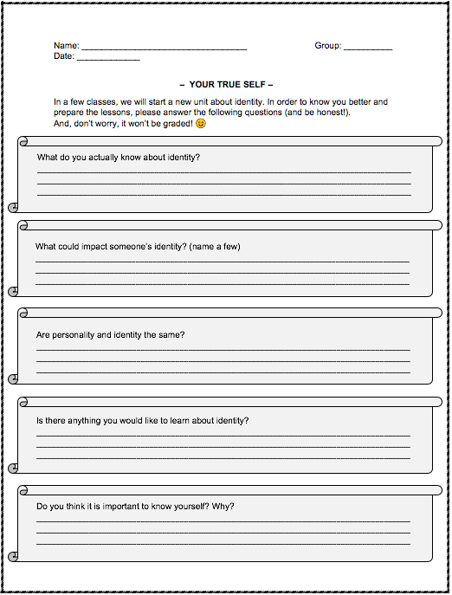

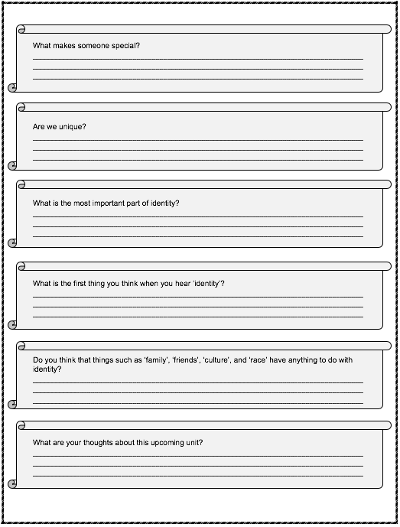

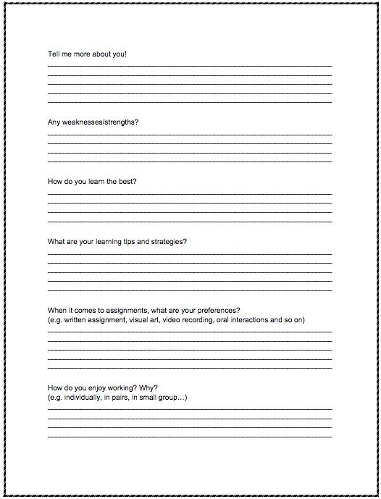

Appendix 2:

|  |
| --- |
| **“Speed Dating”**  Instructions:   1. Teacher will assign you a number (either #1 or #2) 2. All those who were assigned #1 will form a line 3. All those who were assigned #2 will form another line facing the students with #1. 4. Partner #1 will share a dream and how it affects your identity. (you have 2 minutes) 5. Teacher will tell you when it is partner #2 turn. 6. Partner #2 will also share a dream and how it affects your identity. (you have 2 minutes) 7. Teacher will signal when it is time for partner #1 to move to their right (to the next partner). 8. Repeat 4-7 until teacher says the activity is finished. |

Appendix 3:

|  |
| --- |
| **“Speed Dating – Doubles”**  Instructions:   1. Choose a partner you are comfortable with (someone who has received the same instruction sheet as you). 2. Sit in front of another pair. 3. Each person will have 6 minutes to share their dream and how it affects their identity. 4. Each person will help their partner in the explanation. |

Appendix 4:

|  |
| --- |
| **“Speed Dating – Mentee”**  Instructions:   1. Choose a partner you are comfortable with (someone who has received the same instruction sheet as you). 2. Each of you will have 12 minutes to share a dream of yours and to explain how that dream has affected your identity   *Note: A student with the “Mentor” instruction sheet will be aiding each of you with the discussion. |

Appendix 5:

|  |
| --- |
| **“Speed Dating – Mentor”**  Instructions:   1. You will choose a pair of students with the “Mentee” instruction sheet. 2. Help each one with anything they have difficulties with (choosing their dream and/or explaining how it has affected their identity). |

Appendix 6:

|  |
| --- |
| **Names:** .  **Group Discussions Questions**  Have you ever faced any cultural challenges?  What is the aspect of culture you practice the most?  What do you like most about your culture?  Where is your ethnicity evident in the world Where does your traditions originate from?  What do you dislike from your traditions? |

Appendix 7:

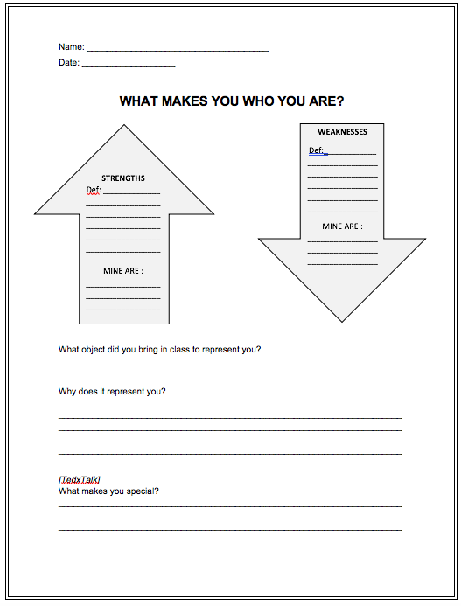

Appendix 8:

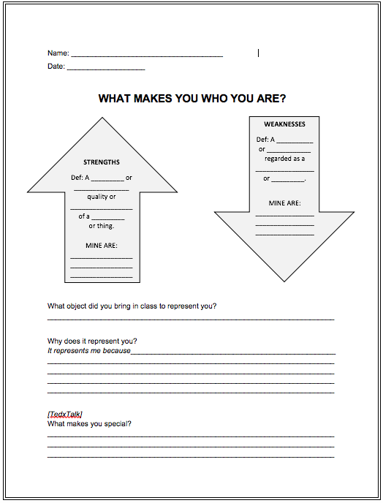

Appendix 9:

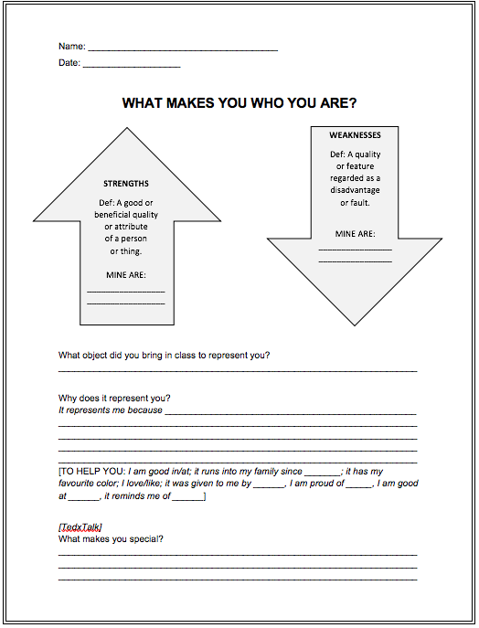

Appendix 10:

