Learning Plan: ELEMENTARY
Title of lesson |  | It’s Springtime! | Grade level | 1
Subject |  | ELA | Topic | Learning about Spring
Relevance |  | It is important for students to understand when the seasons change and what happens in each season. (This time to learn specifically about Spring since it the season we are currently in, and students will be able to see the changes we talk about during the lesson).
Resources Required |  | Springtime PowerPoint, Puzzle pieces, puzzle piece lists, poster board, sticky tack
QEP Subject Area Competencies |  | C4: To use language to communicate and learn – To use language (talk) for learning and thinking & To interact in collaborative group activities in a variety of roles
Learning Objectives |  | Students will understand the main things that happen during springtime.
Essential Question(s) |  | When is Spring? What are the signs of Spring?
Lesson Timing  5 mins | Introduction (hook): |  | Student will know:
 | It’s Springtime – Story bots song about the seasons (students can get up and dance along)  https://youtu.be/NavWWM2iTEw  - What do you know about spring? – students respond with things that they know about spring |  | Students will know when spring is and what the different signs of spring are.
30-40 mins  20 mins | Development (Learning activities – step by step sequential procedure):  Lesson about Spring:  - When does Spring start? – slide  - Students will give answers  - Provide the answer  - What happens to the weather in Spring? – slide  - Students will give answers  - Provide the answers  - What can you wear in Spring? – slide  - Students will give answers  - Provide answers  - What do plants do in Spring? – slide  - Students will give answers  - Provide answers  - What do plants need to grow? – slide  - Students will give answers  - Provide answers  - Hibernation is over! – slide  - Do you know what hibernation is?  - Students give answers  - Provide answer  - Migration time! – slide  - Students give answers for what they think migration is  - Provide answer  - Birds lay eggs and Caterpillar becomes butterfly – slide  - Students watch the videos  - Holidays in Spring 2022 – slide  - Students give answers for which holidays they think are in spring  - Provide answers  - Dance time!! – slide  - Students get up and dance to the “Springtime dance” https://youtu.be/tWgoYgaxQ0E |  | Students will understand:
 |  |  | Students will understand how to recognize signs of spring.
 |  |  | Students will do:
 |  |  | Students will answer questions about spring and complete a spring puzzle scavenger hunt.
 |  |  | Cross Curricular Competencies:
C1: uses information – students will need to use information about spring
C8: cooperate with others – to complete the puzzle students will need to work together
 |  |  | Broad Areas of Learning:
 |  |  | Personal and career planning
 |  |  | Universal Design for Learning/ Differentiation:
 | Closure (transition):  Spring Puzzle Scavenger Hunt with students  - Students are shown the puzzle piece list and are each provided with one.  - They then will search for all the pieces  - Once all the pieces are found, they will work as a class to put the pieces together. |  | FORMATIVE - Assessment FOR learning:
 |  |  | I will be asking students to participate throughout the lesson.
 |  |  | FORMATIVE - Assessment AS learning:
 |  |  | Students will need to participate during the class demonstrating understanding. They will also put together the puzzle.
 |  |  | SUMMATIVE - Assessment OF learning:
 |  |  | There is no summative for this lesson as it serves as an activity for students to learn about Spring.
Further considerations (follow up activities)
There will be no further lessons about explaining springtime and what happens during spring. This was a lesson to be used to teach students about Spring. There will be easter activities closer to easter time.

Reflection:
For this lesson, I will focus on providing the students with plenty of opportunities to participate in the lesson so that it can be as enjoyable and interactive as possible as I believe that being an active learner is the best thing for students.
This lesson is being used to develop student knowledge on the different seasons of the year, for this, specifically Spring.
I will continue to work on my classroom and time management as well as my teacher voice since it needs to be further developed to cater to younger students.

Professional Competencies:
PC1: Act as a cultural facilitator when carrying out duties – in completing this lesson about Spring, a season that occurs every year and that students need to understand, I am acting as a cultural facilitator.

PC6: Manage how the class operates – I will be doing a lot of classroom management for this lesson as there is a lot of participation meaning that, once the participation is done, I will need to maintain student attention and focus on what it is that I am saying.

Resources:
It’s Springtime! Power point
https://docs.google.com/presentation/d/1DfK9Zr2XFw9wCXmvFnSP92wbhwzptQ5fmZsFcuIgg3Y/edit?usp=sharing
Puzzle pieces
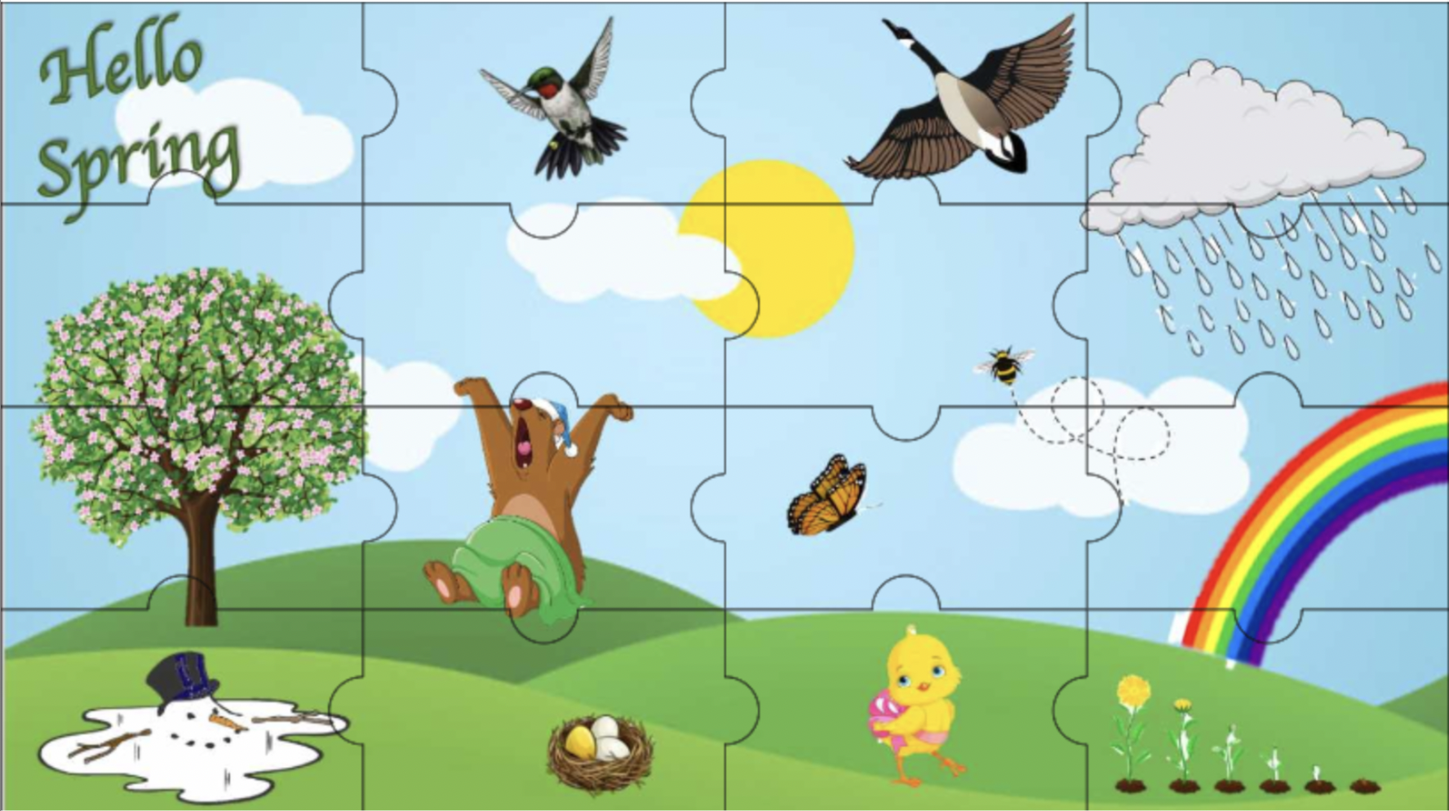
Puzzle piece list
